OPERATIONS & MAINTENANCE MANUAL

(ENTER SERVICE / SYSTEM NAME)

TABLE OF CONTENT

Section 01. ABOUT THE PROJECT
Section 02. CHANGE CONTROL
Section 03. EMERGENCY ESCALATION PROCEDURE
Section 04. EMERGENCY INFORMATION
Section 05. EMERGENCY EQUIPMENT LOCATIONS
Section 06. SYSTEM PURPOSE AND SCOPE
Section 07. CONTRACTUAL AND LEGAL INFORMATION
Section 08. DESCRIPTION
Section 09. EQUIPMENT SCHEDULES AND ASSET REGISTERS
Section 10. OPERATING INSTRUCTIONS AND PROCEDURES
Section 11. OPERATING MANUALS AND LITERATURE
Section 12. MAINTENANCE PROCEDURES
Section 13. SPARE PARTS
Section 14. DISPOSAL INSTRUCTIONS
Section 15. TESTING & COMMISSIONING
Section 16. MODIFICATIONS
Section 17. DRAWINGS
Section 18. MANUFACTURER AND SUPPLIER LITERATURE
Section 19. PRODUCT GUARANTEES AND WARRANTIES
Section 20. CROSS REFERENCING INDEX

About The Project
The Project is a [xxxxxxxx] use project primarily consisting of [enter description] with associated [xxxx facilities], ancillary and MEP service floors.
The building/development’s gross area is ……………. square meters (…………… square feet) above grade, with a total of ……….. Square meters (……………. square feet) including below grade levels.

Change Control
Date | System | Manual Section | Design By | Details Of Change

Emergency Escalation Procedure

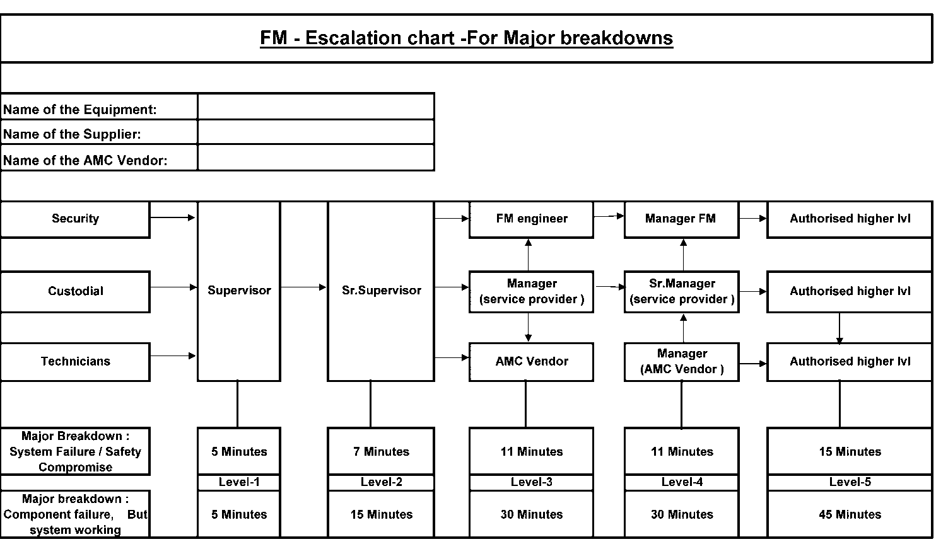
- Add here the procedure for dealing with specific emergencies

Emergency Information
- The names, addresses, telephone and fax numbers of appropriate contacts during the daytime and night time in the case of a fire, leaks, breakdowns, injuries, building shutdown etc. Arrangements for public holidays should also be included’

- A minimum 3 level contact numbers to be given for all emergencies situations

- Fire evacuation plan, assembly points, etc. to be provided in this section

Role | Organisation Name & Address | Phone/Fax & E-Mail Details
Employer |  | Tel:  Fax:  e-mail:
Local Authority |  | Tel:  Fax:  e-mail:
Architect |  | Tel:  Fax:  e-mail:
Services Engineer |  | Tel:  Fax:  e-mail:
Structural Engineer |  | Tel:  Fax:  e-mail:
Quantity Surveyor |  | Tel:  Fax:  e-mail:
Planning Supervisor |  | Tel:  Fax:  e-mail:
Main Contractor |  | Tel:  Fax:  e-mail:
Installing Contractors Details |  | Tel:  Fax:  e-mail:
Maintenance Contractors Details |  | Tel:  Fax:  e-mail:

Emergency Equipment Locations.

- Add drawing and description of location of fire fighting equipment, rising mains and hydrants
- Add Details of known hazards around the asset
- Include Photographs of important control panels under normal operating conditions.

System Purpose and Scope

- Summarise the purpose and scope of the systems and equipment that the manual covers
- Describe the basis of design outlining the design intent and any objectives of the design.

CONTRACTUAL AND LEGAL INFORMATION

This Section describes the historical contracts and names of the original designers and builders

Legal Information | Detail
System Ownership
System Address
Design Team
Consultants
Installation Contractors
Sub Contractor(s)
Installation Start Date
Practical completion date
DLP Expiry Date
Warranty Expiry Date
Warranty / DLP Agent

This section should also contain;
- Test certificates, examination reports, safety and fire certificates
- A statement of any known feature or operational characteristic of the plant or system installed which may produce a hazard
- Any known hazard against which protection can be provided
- Any mandatory requirements relating to safety
- Any other safety precautions that should be observed
- Any other relevant warnings.

Description
- Description shall include a detailed description of the system, equipment or plant designed.
- The description of unit or system and component parts as considered necessary for a proper understanding shall be included.
- The description shall be clearly written so as to ensure that the client fully understands the scope and facilities provided.
- The description shall include simple diagrams as required to explain the layout and /or functionality of the equipment and/or system.
- Details of any special construction methods used or procedures undertaken during the project work shall be identified.
- For the Units, the description shall include for all services provided within the unit.
- Control descriptions shall include descriptions of controls as well as telemetry systems.
- A complete description of all operating sequences shall be included. And also to be provided for systems/equipments expected service life, operational efficiency, etc.
- Include a copy of the relevant specification sections.

Equipment Schedules

- The equipment schedules shall clearly identify all the various types of equipment and devices used the quantities, locations and identification numbers.
- Equipment schedules shall identify equipment basic ratings and types.
S. No. | Description | Model | Manufacturer | Country Of Origin | Quantity | Location

Operating Instructions and Procedures
- All necessary operating instructions shall be included.
- All necessary cautionary and warning instructions shall be included with particular emphasis, in larger bold lettering font if necessary.
- Where operating instructions are in languages other than English, these shall be translated into English and included.
- Operating instructions in languages other than English shall not be included, unless specifically approved by the Project Manager.
- Operating instructions shall include all routine operating instructions. The safety measure prior to start of operation shall be listed and provided.
- All start-up, shut-down procedures, and the interlocks between plant items/equipment shall be included.
- Any emergency operating procedures shall be included as required.
- Summer, winter and any special operating instructions as appropriate are to be included.
- All manufacturers operating instructions shall be included.
- Shall include the faults findings

Operating Manuals and Literature
This shall include manuals for all equipment and systems
- For each equipment item and system, state the function, normal operating characteristics and the limit conditions of operation.
- Design data, design parameters, and assumptions made during design shall be provided for each system.
- Parameter set information shall be provided for relevant systems/equipments.
- Include all performance curves for both Electrical and Mechanical, with engineering data sheets such as (motor, instrument, noise & component auxiliary data sheets) and tests as necessary for the various equipment.
- Include all manufacturers’ technical literature and vendor catalogue for all items of plant and equipment provided.
- Provide diagrammatic drawing, equipment detailed drawing and instrument location drawing of each system indicating principle items of plant and equipment together with catalogue list numbers.
- Include copies of manufacturer’s data sheets for all materials, plant and equipment installed. This shall include contract specific inspection, test plan and approval certificate.
- Technical details and ratings of all materials and finishes are to be included.
- Include all necessary schematic drawings, single line diagrams and interface connections as required to establish clear understanding of the product and/or system.
- Provide clear copy of manufacturer’s original illustrations, general arrangement and assembly drawings where required.
- Operation, control philosophy and block/logic diagram shall be provided for relevant systems/ equipment’s.
- Approved cause and effect matrix shall be provided for all systems and equipments.
- Data shall be sufficient to enable re-ordering of the product, without further clarifications being required.
- All documentation shall be in English.
- Where documentation is only available in other languages, these shall be translated into English and included, clearly stating which of the pages are translated and from which language.
- Manuals for materials and finishes shall include all the building products, applied materials and finishes.
- All weather exposed product details shall include chemical composition and details of installation.
- Immediate check list for general problem/FAQ, Tools list, breakdown history sheet, shall be provided.

Maintenance Procedures
- Maintenance procedures shall include general maintenance procedures as well as specific maintenance instructions as required.
- For all materials and finishes, the manufacturer’s recommended cleaning agents and methods shall be included.
- All maintenance precautions, including detrimental cleaning methods and cleaning agents, shall be clearly identified.
- A recommended schedule of inspection, cleaning, maintenance and repairs shall be provided. As per OEM (Original Equipment manufacturer)
- Trouble-shooting procedures shall be included for all equipment.
- Clear instructions shall be provided for dismantling, repair and re-assembly of equipments/systems including the installation procedure.
- Include all necessary instructions and procedures for Alignment, adjusting, balancing as necessary.
- Servicing and lubrication schedule shall be included.
- Where maintenance is specifically forbidden, this shall be clearly emphasised.
- Names, address and contact numbers of any special maintenance agencies required, shall be included.
- Any special tools or equipment including safety apparel, required for maintenance shall be clearly indicated.
- Maintenance procedures shall indicate disposal methods for equipment and/or material which could be considered toxic wastes and therefore requires being disposed in a special manner.
- All necessary health warnings related to handling of cleaning agents shall be included as required and shall be enclosed with MSDS (material safety and data sheet)
- Copies of the following will be provided with a cleanable and protective surface, to be framed and hung in each plant room and switch room and any other appropriate location:
    - Schematic drawings of layouts showing identification and duties of equipment, numbers and locations.
    - Schedules in form of printed sheets showing the number, type, location, application/service and symbol, and normal operating position of any means of isolation for electrical, mechanical and instrumentation equipments/systems.
    - Control schematics.
    - Location of all plant and equipment items including planed and elevation of showing physical disposition.
    - First aid instruction for treatment of persons after electrical shock.
    - All other items required under Statutory or other regulations.
    - Location of all incoming service and isolating facilities.
- Maintenance procedures shall include frequency of maintenance check / tasks

Spare and Replacement Parts

- Include parts identification as per the manufacturer standard for all each device, equipment, materials and systems for all spares issued.
- For Each system - Provide a list of recommended spare parts for an expected five years of usage.
- Packaging, shipping, prevention handling and storage procedures for each and every spare part shall be provided for all systems/Equipments.
- Spares shall include recommended lubricants as necessary.
- Spare parts list shall be accompanied by illustrations as required enabling full understanding.
- Include list of original manufacturer supplied spare parts with current prices at the time of handover of the project.
- Local supplier details shall be provided including contact person, phone, email, fax, etc.
S. No | Item Description | Item Code | Quantity

Disposal Instructions

Where relevant, information should be provided detailing;
- Any known dangers likely to arise during the disposal of specific items of plant or equipment together with the necessary precautions and safety measures
- Procedure for handling waste specially hazardous waste materials including details of authorised waste handlers and transporters of waste (shall comply with local regulations and international standards)
- Material Safety Data Sheets where Applicable
- Safe working procedures including safety equipment and personal protective equipment where applicable.
- Risk Assessment, where applicable
- Method of Statement for handling such wastes shall be provided.
- Sources from which further advice can be obtained.

Testing & Commissioning
- Each set of commissioning / test sheets to be listed here
- Copies of sheets to be included in each sub-section as defined.
- All testing and commissioning reports, duly certified by the consultant shall be included. Design Calculations and Test Sheets should be included.
- The standards to which the testing has been carried out shall be identified for each equipment and/or system.
- Thirdly party test reports and factory test reports shall be provided for relevant systems/ equipment’s.
- Load discrimination study report shall be provided for Electrical.
- Factory test reports and site commissioning reports shall be provided for other systems like power distribution boards, life and safety equipment, fire fighting system, etc.
- Copy of the test sheets to be appended

Modifications
- Modifications are authorized changes which may affect the safety, reliability, operation or maintenance of a system or any of its components.
- Information on permitted plant or system modifications allowed for by manufacturers or system designers should be included for each system.
- Space must be provided in the manual for recording all modifications and changes as they occur (this would initially comprise a series of appropriately headed blank pages).
- Furthermore it is essential that a procedure is devised and incorporated to ensure all modifications are noted in every copy of the manual, wherever it is located.

As Built Drawings
- A full as built drawing register and to append the required drawings
- For all MEP services provide certified “As- Built” drawings.
- All necessary wiring and control drawings to be included.
- Include for all distribution board schedules.
- Provide “As-installed” wiring diagrams by panel manufacturers.
- Layout drawings indicating locations and areas of various equipment, devices and materials used, as required to establish a clear understanding for the client.
- These must include but are not limited to:
      - Location, including level if buried, of Utility Service connections, including those provided by the appropriate Authority, indicating points of origin and termination, size and material of service, pressure and/or other relevant information.
      - Disposition of depth of all underground systems.
      - Schematic drawings of each systems indicating principal items of plant, equipment, zoning, means of isolation etc. sufficient detail to make it possible to comprehend the system operation and the interconnections between various systems.
      - Details of the principles of application of automatic controls and instrumentation.
      - Diagrammatic dimensioned plans and sections of each system or service showing sized and locations of all ancillaries, plant, equipment controls, test points and means of isolation etc. including any items forming an integral part of the work shafts, chimneys etc.)
      - All terminals/cables etc. will be identified by size/type and duty/rating as recorded from the approved commissioning results.
      - Detailed drawings/diagrams/schedules for all systems, including controls, showing origin, route, size, type, length and identification of each circuit. Routes will indicate if service is surface mounted, concealed in wall chase, if floor screed cast in-situ, above false ceiling etc.
      - Details of co-ordination, notification of fire alarm, security, control and instrumentation and similar systems provided as part of the Works.
      - Details of show interconnections between the works and equipment or systems provided by others to which wiring and connections are carried out as part of the Works.

10 Location and identity for each room or space housing plant, machinery or apparatus. Dimensioned plans and sections at a scale of 1:20 of plant rooms, service subways, trenches, ducts and other congested areas where in the opinion of the Construction Manager smaller scale drawings cannot provide an adequate record. Indicate the location, identity, size and details of each piece of apparatus.
- Manufacturer’s drawings of equipment indicating:
- General arrangement and assembly of component parts, which may require servicing.
- Internal diagrams together with sufficient physical arrangement details to locate and identify component parts.
- Schedules as require locating, reference and providing details of ratings and duty of all items incorporated into the Works together with all fixed and variable equipment settings established during commissioning.

Manufacturer and Supplier Literature
- Summarized list of manufacturers and suppliers used for all the products used.
- The names, address and telephone numbers and fax numbers of the contractors who have carried out the works, including all sub-contractors and any specialist testing or installation agencies, shall also be included, if not detailed in Section 9
- Each element of manufacturers’ information to be listed here – as per typical examples shown here - using tables provided and level 2 headings. The manufacturers are to be listed in alphabetical order.
- NOTE: ONLY LITERATURE RELEVANT TO INSTALLATION IS TO BE INCLUDED. COMPLETE CATALOGUES ETC. ARE NOT REQUIRED.
- Original copies to be included in each sub-section as defined.

Product Guarantees and Warranties
- Copies of all guarantees, warrantees and maintenance agreements shall be included.
- All start and end dates to be included.
- Schedule of warranties, Guaranties, and extended warranties, shall be provided with expiry date

Cross Referencing Index
Section 20 of The Manual is the Cross Referencing Index. This shall be a comprehensive alpha/numeric list of specific information and shall provide easy reference to the relevant book, section and page number. This will enable the reader to detect with ease, the page/s which accommodates required facts and data.
An index should be provided of all record drawings supplied during the course of the installation work, identified by a number and title. The index should also include a schedule of all drawings supplied by manufacturers and suppliers during the course of the installation work, e.g. control panel wiring diagrams (for larger projects the index may be computer-based.)

